Bahria University,

Karachi Campus



LAB EXPERIMENT NO.

**07**

LIST OF TASKS

|  |  |
| --- | --- |
| TASK NO. | OBJECTIVE |
| **1** | **Write a python program which can read any dataset and implement KNN for multiple labels plot your result** |
| 2 | Implement KNN without using Sklearn Library |

Submitted On:

**LAB 07 (K NEAREST NEIGHBORS)**

**EXAMPLE**

**SOLUTION**

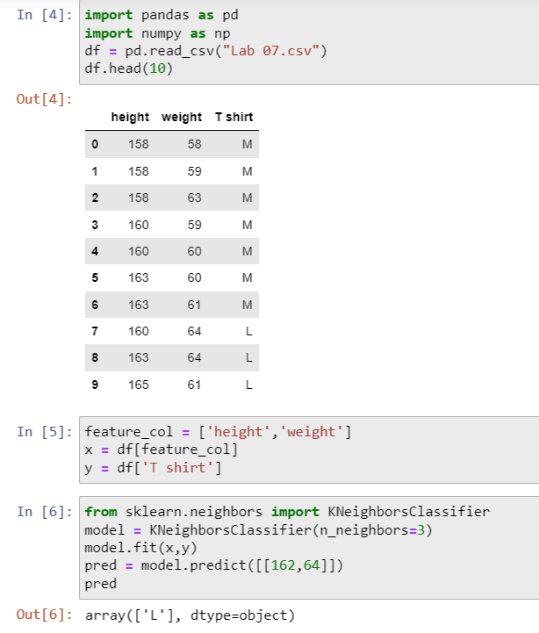

**TASK 01**

**Write a python program which can read any dataset and implement KNN for multiple labels plot your result**

**SOLUTION**

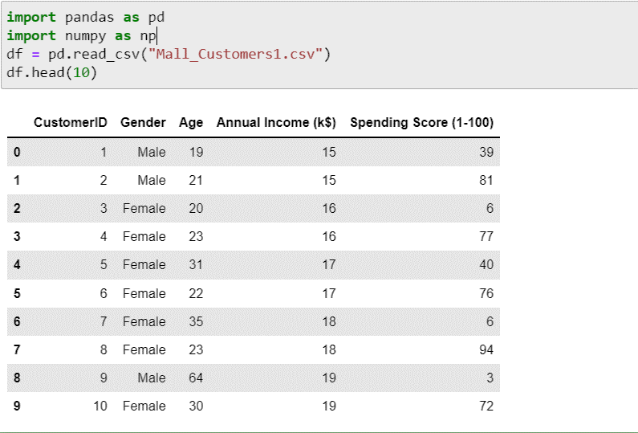

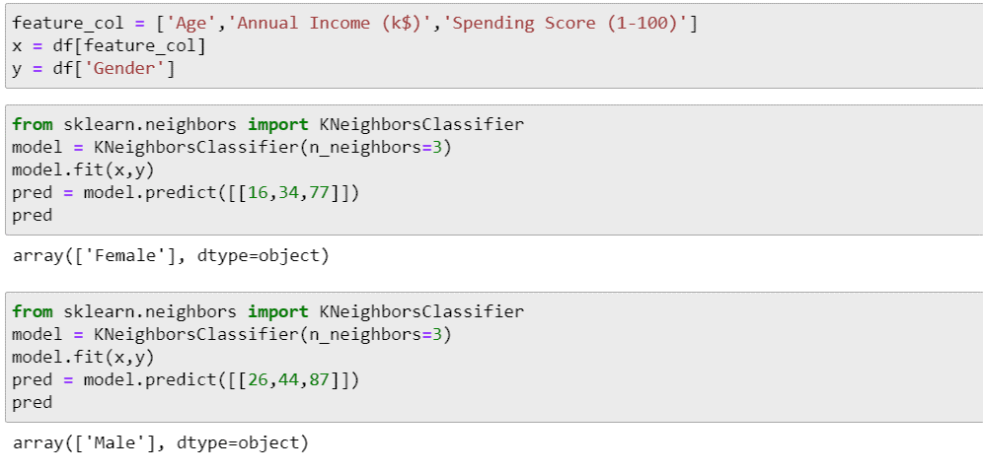

**TASK 02**

**Implement KNN without using Sklearn Library**

**SOLUTION:**

